View Appointments

**#1**

When appointments have never been scheduled

Output:

*No Scheduled Appointments*

*No appointments have been scheduled. Appointments can be scheduled from Schedule Appointments Module*

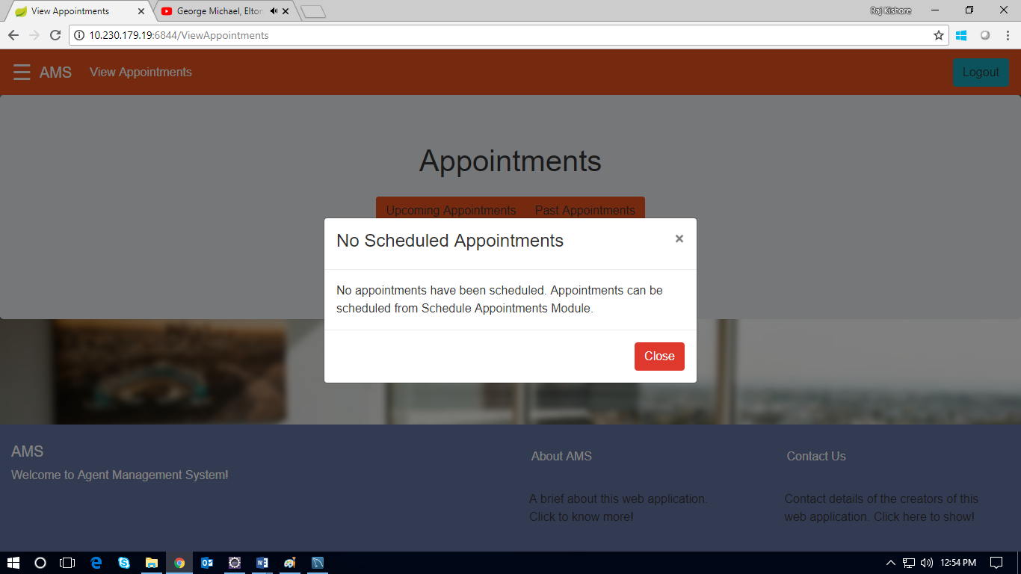

**#2**

When appointments have been scheduled by the customer

Output:

1. Upcoming Appointments

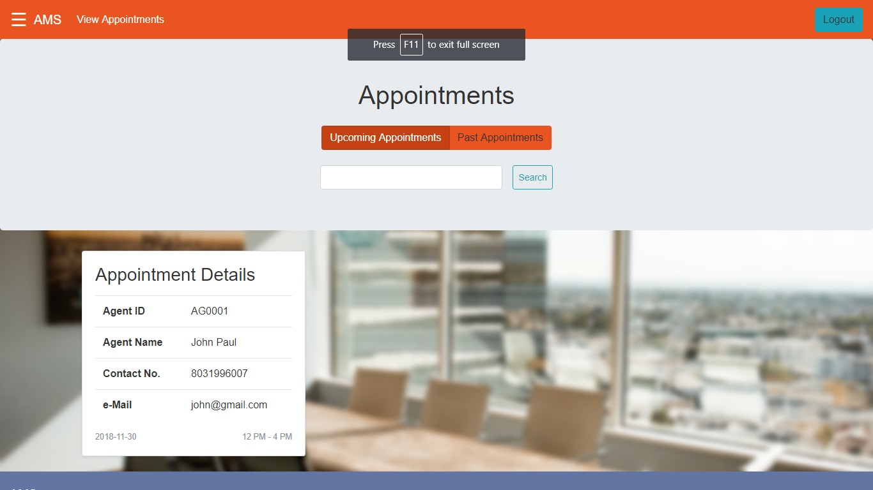

1. Past Appointments

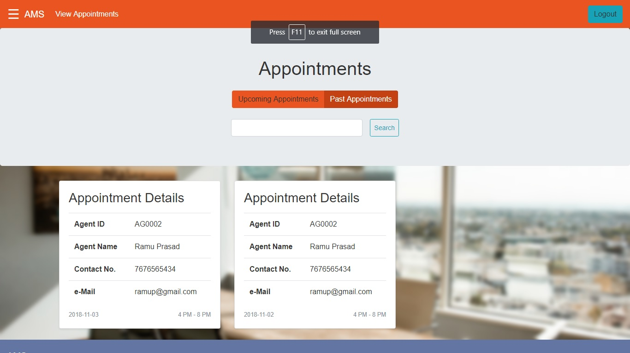

**#3**

Search by date

Key: 2018-11-02

Output:

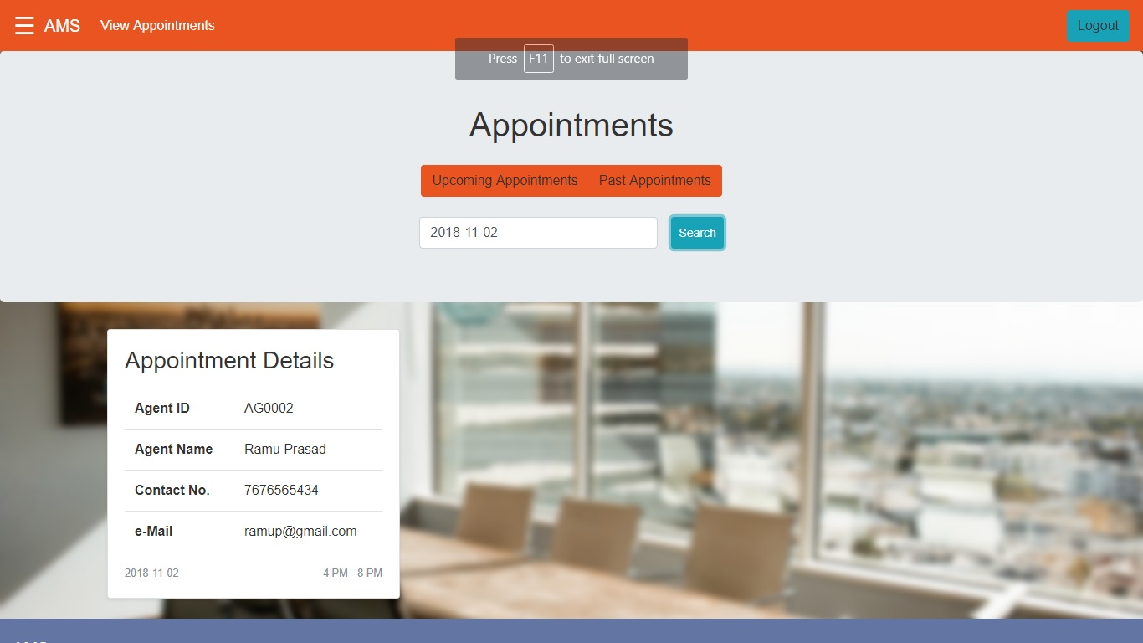

**#4**

Search by Agent ID:

Key: AG0002

Output:

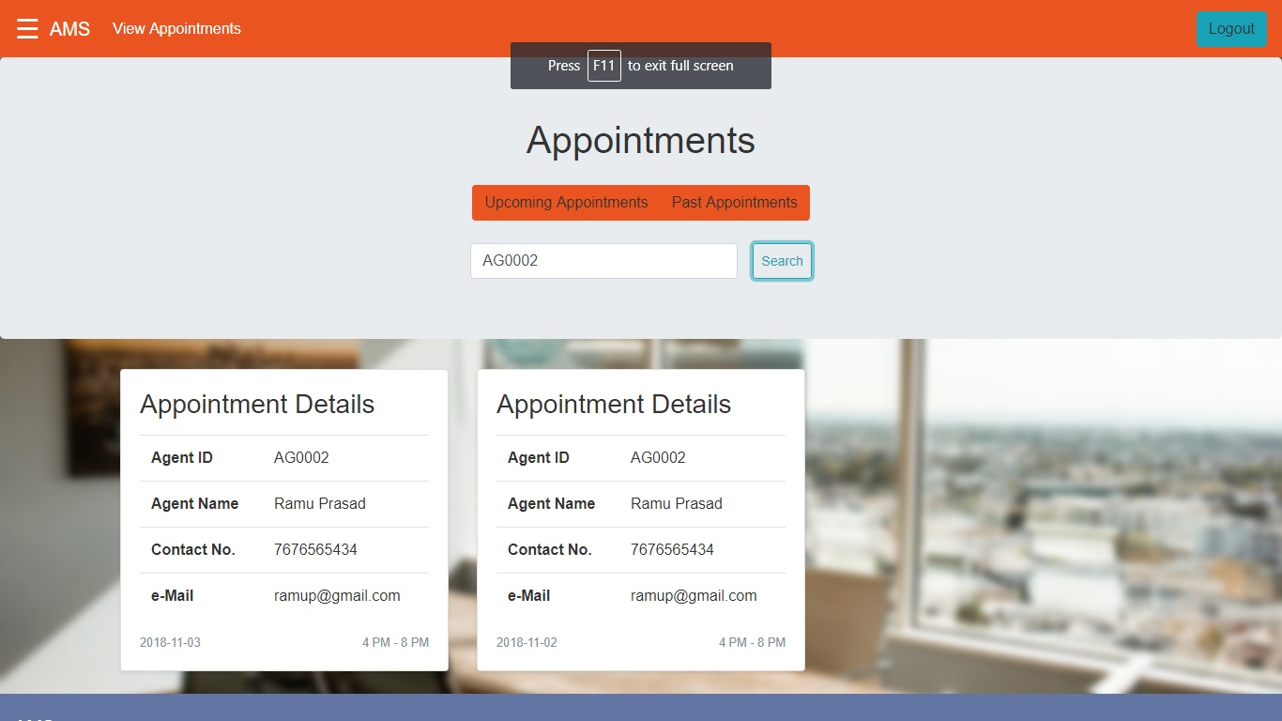

**#5**

Search by Agent name:

Key: john

Output:

